Ollama assignment:

- Ollama qwen2.5:0.5b model pull
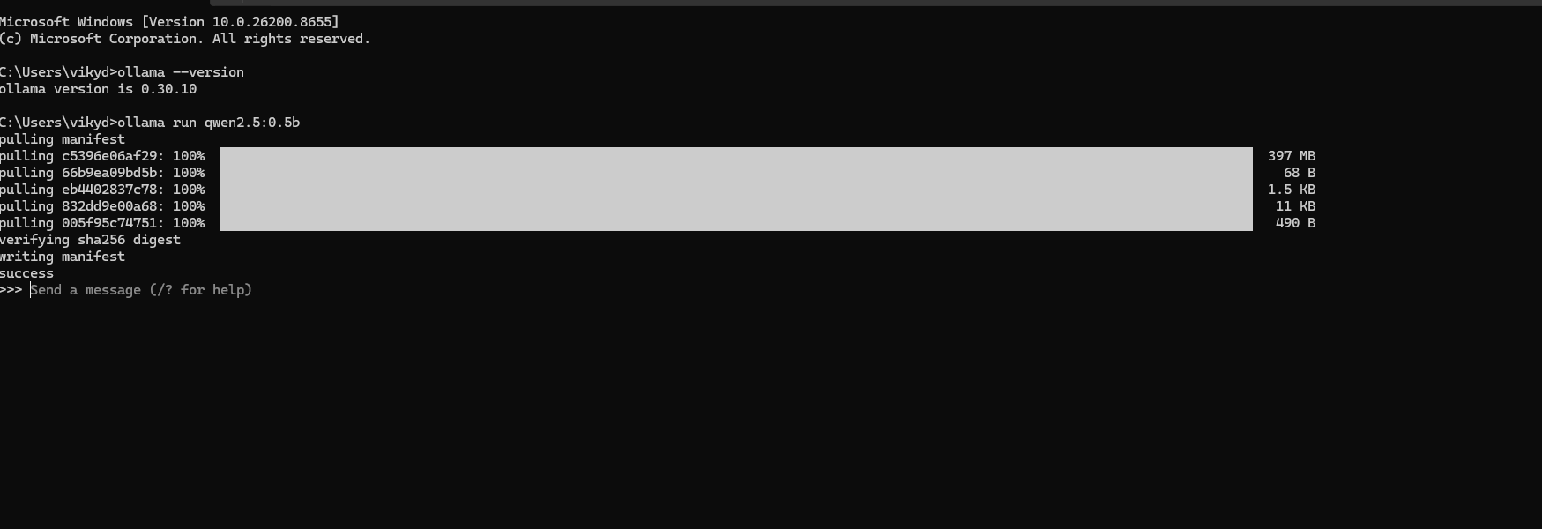

- qwen2.5:0.5b model chat 1
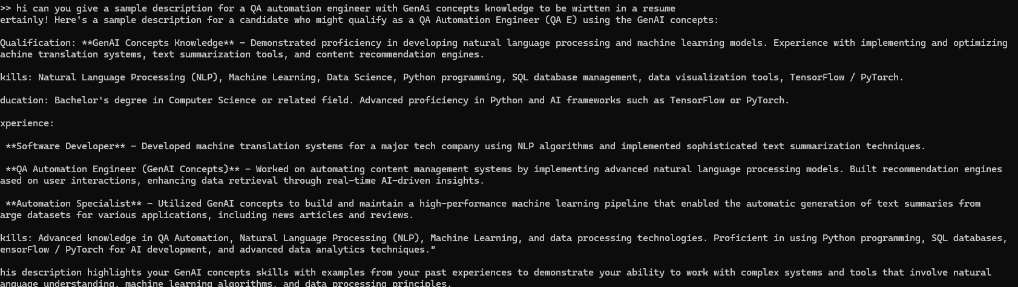

- qwen2.5:0.5b model chat 2
